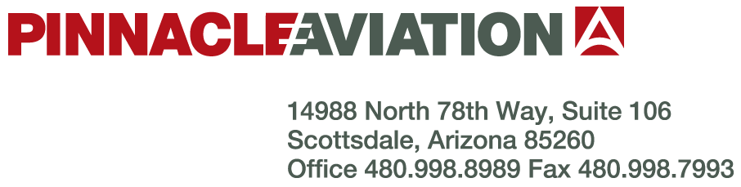

AIRCRAFT SALES EXCLUSIVE LISTING AGREEMENT

This Agreement is made this ____ day of _______________, 2022 by and between Pinnacle Aviation, Inc., whose address is: 14988 N. 78th Way, Suite 106, Scottsdale, Arizona 85260, Telephone Number: 480-998-8989, Facsimile Number: 480-998-7993, (hereinafter referred to as (“Pinnacle Aviation”) and ____________________________ whose address is: ____________
____________________________, Telephone Number: _______________, Facsimile Number: _______________, (hereinafter referred to as “Seller”).

WITNESSETH: Whereas, Seller is the owner of the following aircraft:

MAKE: MODEL:
SERIAL NUMBER: REGISTRATION:

(hereinafter referred to as “Aircraft”) and Pinnacle Aviation is engaged in the business of selling and brokering business and commercial aircraft and has the necessary capabilities to perform the functions incidental to this business; and Seller desires to sell the above described Aircraft.

Whereas, Seller desires to enter into an Agreement with Pinnacle Aviation to promote the sale
of the Aircraft. to promote the sale of the AIRCRAFT.

Now, therefore, Seller agrees as follows:

1. SCOPE OF AGREEMENT: Seller hereby appoints Pinnacle Aviation as its exclusive broker during the term of this Agreement to produce the sale of the Aircraft.

2. OBLIGATION AND COOPERATION OF PARTIES: Pinnacle Aviation represents that they have adequate capabilities to conduct a continuous sales campaign for the sale of the Aircraft to the business and commercial transportation market, and will actively pursue the representation and sale of the Aircraft in the respective marketplace. Seller agrees to make the Aircraft available for inspection and to support the sales efforts of Pinnacle Aviation provided that such inspection does not interfere with Seller’s normal operations, to refer prospective sales to Pinnacle Aviation and to otherwise support their sales efforts. Both parties agree that in their dealings with customers they will quote identical prices for the sale of the Aircraft. The price level for the quotation will be determined as set forth in paragraph 3 of this Agreement. Seller represents that it owns the Aircraft covered by this Agreement free and clear of all liens or encumbrances or will produce good and marketable title to the Aircraft at the time of transfer.

3. SALE AND PRICE OF AIRCRAFT: Seller agrees that if Pinnacle Aviation is successful in obtaining purchasers for the Aircraft, Seller will sell such Aircraft to purchasers at the price agreed upon. The Aircraft will be made available for delivery on a mutually agreed upon date to the new owner at a mutually agreed upon location for a CASH PRICE of not less than: $______________. USD. However, all offers will be submitted to the Seller for acceptance or rejection.

4. COMPENSATION: Pinnacle Aviation compensation will be $____________. USD based upon the sale and final closing of the Aircraft. Such compensation shall be paid to Pinnacle Aviation at final closing by Escrow Agent. Pinnacle Aviation will advertise and promote the sale of this aircraft for $______________. USD.

5. TERM: The term of this Agreement shall be commencing on the date of the Agreement
and shall continue for _______ days. If, at the end of the _______ days, the Aircraft is still not sold, this Agreement may, at the option of the Seller, be extended for an additional term of ________ days. Pinnacle Aviation will advise Seller in writing of all prospective buyers within Ten (10) days of the date of expiration of this Agreement. ALL such prospects shall remain exclusive Pinnacle Aviation prospects, and should one of said prospects purchase said Aircraft within (l20) days after this Agreement expires, Pinnacle Aviation shall be due and payable the compensation as defined in paragraph 4 herein.

6. ADDITIONAL PROVISIONS: Seller will provide Pinnacle Aviation with current times on major components and all other pertinent data and details as to the condition
of the Aircraft to advertise and represent the Aircraft properly. Demonstrations will be made only as necessary and approved by Seller. Costs for such demonstration will be paid in advance by the prospective purchaser.

7. HOLD HARMLESS: Seller will assume all liability arising out of the use, demonstration
or possession of said Aircraft and agrees to indemnify, protect, defend and save harmless Pinnacle Aviation, it’s officers, directors and employees with respect to any claim, suit, action, or judgment of any kind arising out of such use or possession except claims based upon negligence, wrongful conduct, or breach of obligation of Pinnacle Aviation.

8. REPRESENTATION: It is understood and agreed that Pinnacle Aviation shall be construed as an independent contractor for purposes of this Agreement and not an agent or employee of Seller or its affiliates or divisions and that Pinnacle Aviation is not authorized to bind Seller or its affiliates or divisions and that no legal obligation of the parties shall become an obligation of Pinnacle Aviation by reason of this Agreement.

9. ASSIGNMENT: The Agreement may not be assigned by either party without the prior written consent of the other.

10. NOTICES: All notices and requests under this Agreement shall be in writing, via U. S. Mail or facsimile to the appropriate party to the address first stated above.

11. STATUS AND MODIFICATION: This Agreement is the entire Agreement between the parties and supersedes all previous arrangements on the subject matter whether oral or written. The Agreement shall not be modified or amended except by an instrument in writing signed by duly authorized representatives of Seller and Pinnacle Aviation.

IN WITNESS WHEREOF, the parties hereto have caused this Agreement to be executed
by their respective duly authorized officers or agent as of the date first above.

SELLER: PINNACLE AVIATION, INC.

as SELLER: as BROKER:
By: By:
Name: Name: Curt Pavlicek
Title: Title: President
Date: Date:
Telephone: Telephone: 480-998-8989
Facsimile: Facsimile: 480-998-7993

